Ivybridge
Youth for Christ

Annual Report September 2023
- August 2024

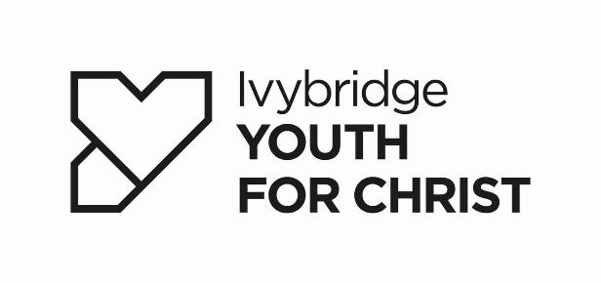
Chairman’s Report for Ivybridge Youth For Christ

I am pleased to report that Ivybridge Youth For Christ is continuing in its ministry of reaching out to many, many young people across our local patch of the South Hams to share the love of God with our young people.

It’s been a positive year where the financial uncertainties that had threatened the ministry a year and more ago appear to have diminished and a new influx of trustees are in place to provide stability and direction.

So many positive things have happened over the year that I cannot begin to do them justice here, but Elis will be referring to some of them in his much fuller report. Having said that, I do have to flag-up the powerful witness that Elis and the Team have provided to the town after the tragedies at the Community College. I am reminded of God’s Covenant with Abraham where God said that through his offspring ‘all the families of the earth will be blessed…’. Through Ivybridge Youth For Christ, so many families have benefitted (both directly and indirectly) through the work of the Team.

It remains for me to extend a truly massive ‘Thank You’ to all those who hold the ministry in their prayers, support it financially or give of their time, skills and resources as active volunteers. You may not see the results of what you are doing on a cold and wet winter evening but you are ‘walking the walk’ of God’s love and may well be the only source of light and love in a young person’s world.

Director’s Report for Ivybridge Youth for Christ

Behind the scenes it has been a year of change, however, I am grateful that the work with young people has continued unhindered. As the year ended, we recruited some new trustees, and the charity was on a stable footing financially. We are greatly encouraged and look forward to building on this from September 2024.

The 2023-24 youthwork year started with the ‘end’ of our Summer Programme, a set of workshops taking place in the Youth Venue. A board games afternoon was our final event. As a result of this summer of activity, new members joined Wired – a great start to the year.

Ivybridge Community College C.U.’s (ICC)

Rock Solid (Year 7-11) – Wednesday lunchtimes

Rock Solid Christian Union continued throughout the year at Ivybridge Community College. During the group, the young people enjoy games, snacks, videos, talks and discussions. Discussions this year developed from Youth for Christ material, which over the year featured topics such as Star Wars, The Fall, Nicknames for Jesus, Parables, Fruit of the Spirit, Rest and Self-Care, Being Careful About What We Watch, Music and Emotion, Euro 24, The Olympics, as well as the usual Christmas and Easter sessions.

Over this academic year, we have seen an increase in the number of young people from local church families attending. Pupils come from a wide range of places including Modbury, Ringmore, Wrangaton, Bickleigh and Buckfastleigh, as well as Ivybridge.

We are extremely grateful to the teachers who have helped facilitate this group, either as a lead, whilst I was away, or as support when others aren’t available.

As the year ends, plans are being firmed up to re-start the older ICC group – Orbit from September 2024. This club has not met since the start of the pandemic in March 2020. A volunteer, Jon, is keen to take the reins, hoping to start on Thursday lunchtimes in mid to late September once all the clearance checks have been completed.

It was exciting to see that 55 different young people attended Rock Solid during 2023/24. Some of them also accessed the Youth Alpha course that ran in Summer 2024.

Bereavement Support at ICC

Sadly, in November 2023, during GCSE mocks, there was another tragedy involving a pupil at ICC. Following contact from a member of the ICC leadership team, whilst the staff and some volunteers were at a Kintsugi Hope Tour, we got the news and were asked to gather a team to support pupils struggling to come to terms with the news.

We provided ways for young people to express their grief, such as facilitating the writing of messages about their friend on paper and using scratchart as a creative distraction. On top of general support, we had one-to-one sessions with youth at school. This included a member of Wired and a Christian young person, who had asked for support. I was also able to do some group sessions.

The advice the school was receiving was for pupils to be encouraged back to lessons as soon as they were able and so we opened up the youth venue some evenings as a supplement to the support that they received in school. This happened for 3 Tuesdays and offered a place for them to gather and support each other. The young people valued this opportunity, and I am grateful to the staff and volunteers who enabled this to happen. The long-term impact has seen them still coming to The Bridge Project, months later.

During this time, I was also involved with a parent and family wellbeing and support evening at the college. This was an event for parents to see what the local town has to offer.

Visit of Dr Andy Bannister from SOLAS Centre for Public Christianity

In March 2024, Dr. Andy Bannister from SOLAS Centre for Public Christianity led a lesson with Year 13’s at Ivybridge Community College. Andy is a very gifted speaker and was able to share his knowledge of the Christian faith and how it contrasts with Islam as he spoke about evil, sin, suffering, relationship with God, and guidance. This opportunity arose following an invitation from Mark Oliver (Chair, Churches Together in Plymouth) to approach ICC asking them if they’d like to make the most of this opportunity.

Connecting Christian youth who live in local villages

In November 2023, we held our termly Connect session at the Youth Venue. The original idea behind Connect was to gather young people from small rural Christian groups. Over the months, the church groups stopped accessing this provision, although members of Wired and other young people came along. On this particular evening, we had a new member, who really appreciated the evening and consequently joined Rock Solid.

However, as the event was not really meeting its original aim, Rev Matt Rowland and Sara Chapman, from Modbury met with us and we decided to stop the event and concentrate instead on taking youth to other larger events such as Kingsbridge Unite, to the new event that is being planned in Plymouth, or to summer events such as Spree or Satellites.
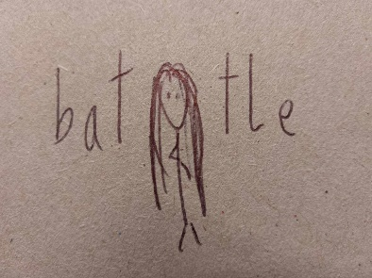
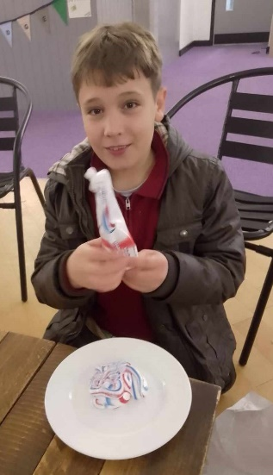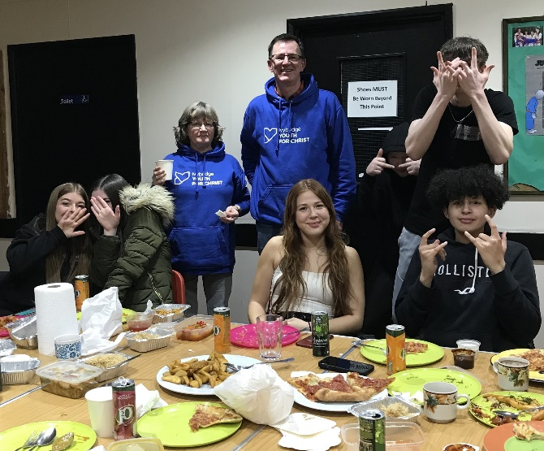
Rock Solid Activity Connect Activity The Bridge Project South Brent Chinese

The Bridge Project – South Brent – Youth Bus at the Rec
Wednesday evenings until Christmas 2023

The Bridge Project continued meeting on the bus until Christmas 2023 with 42 different young people accessing the younger session and 24 different young people accessing the older session (the average attendance per week being 17 and 5 respectively).
We were visited by university lecturer consultants who were looking into community youth provision in the area in October. During this term, I met with Rev. Gina Radford to plan for the transition of this project to our new location in the Recreation building.

The Bridge Project bus, which is no longer is use for the club – failed an MOT in the Spring and no-one seemed to be able to source the correct parts to fix it. As we headed to September 2024 decisions about its future would need to be made.

The Bridge Project – South Brent – Inside the Rec
Monday evenings from January 2024

From January 2024, we entered our new phase by moving into a building. This proved successful with young people being able to take part in activities such as table tennis, pool, table football, bagatelle, colouring, and board games. We now have a bigger, warmer space with better access to toilets, and a kitchen to make drinks in. Staff and volunteers are now able to strike up conversation with young people in a more relaxed setting.

We were pleased to be joined by Christina, who completed the volunteer recruitment and safeguarding arrangements in time to join the newly expanded work. She is proving very helpful and reliable. Further recruitment of volunteers is needed, however, despite several expressions of interest, none have come to fruition yet.

Our next step for young people was to gradually bring in more life-enhancing activities, greater contact with parents/guardians, and more faith discussions or experiences.

At one point in the year, a couple of members in the older group became unwell due to being affected by a substance that they’d inhaled. This led us to review our need for additional volunteers to be first aid trained and to offer first aid information to the young people themselves. We are grateful to Matt, a paramedic, who gave his time on a couple of occasions to offer some informal training. This training gave them the knowledge to look after others (and each other) both inside and outside the club in future.

Following a great conversation with the older group in the Spring, we organised a Chinese takeaway night for our last session before Easter. The young people who initiated it were all willing to pay for their food, but they kindly made sure that there was other free food available for those who either couldn’t afford it or who didn’t like Chinese food. It gave us a good opportunity to link with parents via our consent forms and be aware of dietary requirements.

St. Petroc’s Church administer a grant of £5K that they obtained for this work. We invoice them monthly for the time and resources spent on this new phase. We are grateful to the Rec. building committee who have been very proactive in finding part of the funding that will help us avoid paying the £10/hour rent for the year. They changed their hire agreement to say that they’ve waived our fees for the entire 2024 calendar year.

We broke up for the summer at the end of June due to team holidays and School Enrichment weeks, holding another end of term meal for the older group. This was a much cheaper version (pizza and chips) due to parental budget pressures. Initially we covered this cost but then provision came via a specific donation from one of our supporters whose great-grandchildren very much enjoy attending the group.

It is encouraging to report that 85 different young people attended The Bridge Project in South Brent during 2023/24.

In terms of finance for this project, as well as the fund that St. Petroc’s church administers, we also received significant funding from other churches, organisations, and individuals connected with South Brent which we are grateful for.

The Bridge Project Ivybridge - Friday evenings at The Bridge Youth Venue

Session 1 - Years 6,7 & 8 meet from 6.30-8pm
Session 2 – Years 9+ meet from 8.30-10pm

Normal sessions include the opportunity for young people to have hot chocolate and biscuits, play Xbox, board games, table tennis etc. It is a relaxed environment and a place of safety.

As mentioned previously, in addition to our normal sessions, we offered 3 after school sessions on Tuesdays to support young people affected by the death of a Year 11 pupil at ICC. The average attendance at this was 13 and the sessions were well received.

Around Easter, the younger session became quieter as we re-enforced the correct age restrictions, but it was encouraging to see newer younger ones attend and to receive enquiries from parents about the younger session and how suitable it is for their child. We’ve subsequently had good feedback as to how much their child has enjoyed themselves.

We continue to liaise with the Police and had good first contact with Roberta, a new police officer in Ivybridge.

The team continued to grow with both Elaine and Helen joining the team as volunteers. We are grateful to all our volunteer teams for giving their time and energy. We are also grateful for financial support from a supporter who has offered to provide finance for consumables on a regular basis, as well as Ivybridge Town Council providing £400 towards the work at the beginning of the year.

A huge number of different young people (279) accessed sessions at The Bridge Project in Ivybridge during the 2023/24 academic year.

18+ Work

We continue to maintain relationships with some young people beyond their time in our groups and when they are adults. Somes examples include a Christmas craft event which Helen went to with a local young person, a summer trip to Bigbury Beach with 2 young people accompanied by Helen and our volunteer Sara. Various meet ups in a local café by myself and Helen with young adults.

Wired Youth Group – Thursday evenings at Ivybridge Methodist Church

Wired has had an encouraging year, with growth in numbers following the summer programme, good links with the church and some great fun interspersed with important teaching.

We have continued to build the relationship between Wired and the local church – Ivybridge Methodist Church (IMC). We encouraged members to attend their Light Party. Wired as a group, decorated the church Christmas Tree ready for the Advent Market and helped make the Christmas Advent Wreath with one of our volunteers. The group were invited to light the candles on the wreath in the service on 17 December and were pleased to do so. Some of Wired also attended the Christingle Service. We are keen to encourage these connections.

During Autumn, one of the most popular sessions of Wired was the ‘pea fayre’ which involved lots of challenges including how many balls you can throw in a basket in a minute! The Christmas party was also popular, with members thrilled to receive gifts of chocolate and a calendar from the local tourist attraction Pennywell Farm.

Teaching wise we looked at the nicknames of Jesus – Light of the World, Teacher and Saviour, from British Youth for Christ resources. At least one person has responded to talks indicating they would like to know more about God.

Activities during the Spring included making pancakes and chocolate bark. We had a visit from Cluna Donnelly, Ivybridge’s Community Connector, who talked to the young people using questionnaires regarding loneliness and isolation. She provided pizzas. At the end of one session, a teenage mum we work with came along with her baby to visit. A gift and card were given, and she was very touched. She then was linked up with IMC’s baby group.

Before Easter, we were pleased to be joined by 2 guest speakers – Zoe and Mark Haydon. Zoe works at Pennywell and used to be a church youth worker and Mark leads the Foodbank in Plymouth. Both shared their testimony and the young people listened very attentively.

Our Easter special saw us hold a ‘chip run, rating 5 different takeaway outlets in Ivybridge, giving scores on various things such as service, taste, packaging, etc. We gave a prize to the winning takeaway. We then went back to the youth venue and used the Resurrection Egg resource to retell the Easter account.

The Summer sessions looked at a series on Love Languages, incorporating Bible teaching with each session. When we looked at the gift of time, we held a skittles night of fun and were joined by a young leader from Plymouth Methodist Central Hall, who wanted to see how we ran our club and who was also a tremendous help in lifting and shifting the portable skittles alley. To conclude the series, the young people enjoyed a wooden craft activity using nails and string to make a heart.

We ended the Wired year with a mini-series about Joseph culminating in a showing of the West End musical on video. We also held our popular end of year Scavenger Hunt!

19 different young people attended Wired in total during 2023/24.

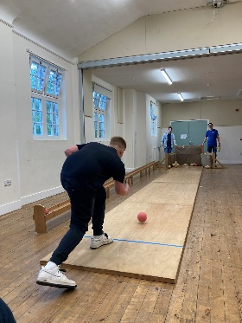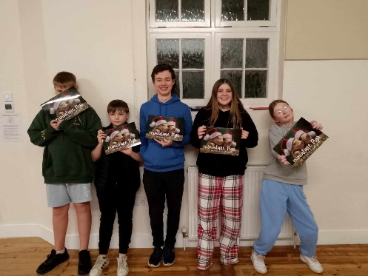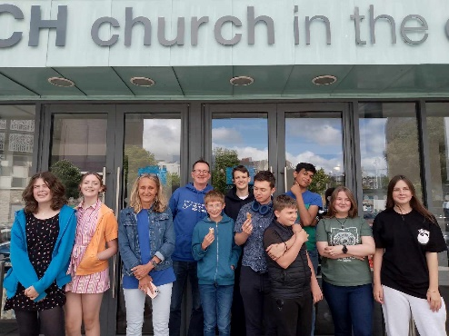
Wired Bowling Wired Christmas Party Youth Alpha Away Day

Youth Alpha – Wednesday evenings at The Bridge Youth Venue, 4.30-6pm.

The summer term was exciting with the charity’s first Youth Alpha course for a few years. This was held in response to the awareness that some young people from Wired had been keen for a while to explore faith in a deeper way. The course launched with 11 regular attendees made up of young people from Rock Solid, Wired and other connections.

We recruited a new volunteer, Kerry, who was a very specific answer to prayer from our March prayer meeting and she did exceptionally well. Helen also volunteered her time to serve on Youth Alpha and organised the food rota. Many kind-hearted local Christians produced cakes, and even main meals for the course. The charity was also given specific donations for Youth Alpha. All in all, other than Elis’s wage, the course proved to be self-funding.

We held our Alpha Away Day on 6 July at PMCH in JC’s youth café. We were grateful to be given this free of charge. The young people loved JC’s, as well as our visit to an ice cream parlour in Plymouth after lunch. Upon reflection, we covered rather a lot of material on the Away Day. Perhaps a weekend next time? However, even with a lot of teaching we were pleased that a few people indicated that they would like to start following Jesus. Praise God.

On 9 July, I attended a pre-launch meeting in Plymouth for the new Youth Alpha series that is being filmed. Alpha is hoping that many youth groups will run the courses in January 2025. We are praying into our post-Alpha strategy and preparing to potentially run future courses, hopefully with the help of the young people themselves.

Impact Youth Group – Modbury

With Aimee no longer placed with us, our involvement with Impact came to an end at the end of the previous academic year. We are pleased to hear from the family worker that the group has grown this year and continues to be popular.

Unite Youth Service, Kingsbridge

In September, 3 youth went with Elis and a volunteer to the Unite Youth service in Kingsbridge led by Kingsbridge Youth for Christ.

Primary school assemblies

Although we primarily work with those of secondary school age, we have a significant outreach to primary school children as well. This year, I had the honour to lead assemblies for 2 different schools. Our usual contact with Cornwood Primary School continued with an assembly on the topic of Advent at the end of November and The Power of our Words in June. In early December, I led an assembly at St Catherines Primary, Heathfield, on the topic of Why did God send Jesus.

Shine Holbeton – Wednesday lunchtimes at Holbeton Primary School – KS2

Helen continues to lead both Shine Holbeton and Shine Newton Ferrers with the support of volunteers from the local church.

Throughout the year, the group looked at the topic of Miracles. In the Autumn that meant studying some Old Testament miracles and the miracle of the birth of Jesus. In the new year, they moved onto New Testament miracles including the wedding at Cana, feeding the 5000 and calming the storm. The stories are backed up with activities, for example the children enjoyed marble painting a sea background for their picture of Jesus calming the storm.

In the Spring, to coincide with Valentines Day, Helen did a short series on love – loving one another (using a UV pen to find a bible verse hidden around the room), loving others (using a fairtrade beetle type game) and God loving us (looking at John 3:16).

In the lead up to Easter there were some wonderful sessions where the children produced a suncatcher cross craft, followed a Bible Society Easter Trail, and heard the Easter account through the Resurrection Eggs Resource. We were also able to give out some Fairtrade chocolate eggs and an Easter ‘Comic’ with Bible puzzles and the Bible account included.

Following Easter, the club carried on its theme of miracles and moved onto looking at healing - such as healing of the leper and Lazarus being raised. At Pentecost the children made some wooden spinners with fire and a dove illustrated on them. We also looked at miracles following Jesus’ ascension such as Peter escaping from prison.

At the request of the children, Helen ran a colouring catch up session one Friday lunchtime. As the regular club is short (due to the lunchtime at the school) it often doesn’t allow time for finishing colouring. Whilst they coloured, some very good conversations were held.

The final miracle the club looked at was the miracle of creation. Some funny globe crafts were made, and the children were encouraged to care for the earth. During the final session Helen led a review of the year. It was very encouraging how much they had taken on board. They simultaneously enjoyed decorating biscuits.

Over the year 19 different children have attended the club. Helen is joined by 2 volunteers at Holbeton, and we are grateful for their input.

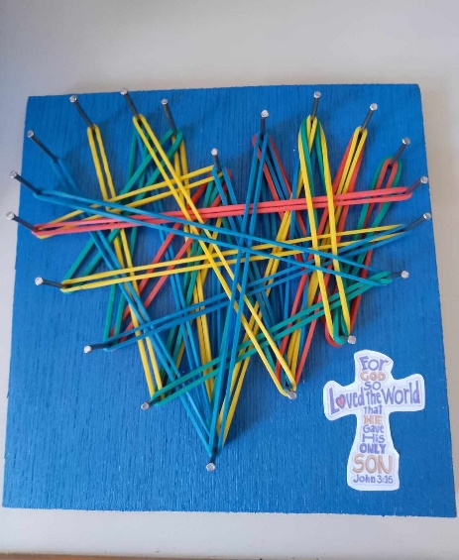 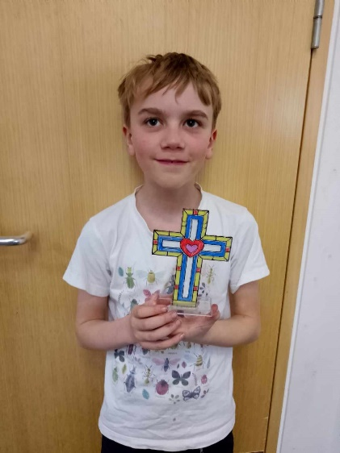 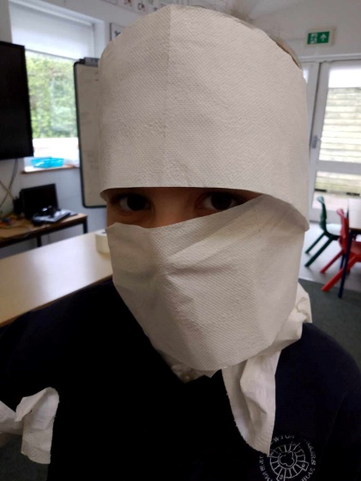Ho
Holbeton Craft Newton Ferrers Easter craft and game

Shine Newton Ferrers

Shine Newton Ferrers follows the same pattern as Holbeton. We have a bit more time to explore topics given that it is an after-school club. For example, with the wedding at Cana, children were able to decorate a terracotta pot to remind them of the story, and for the feeding of the 5000 we looked at the miracle whilst eating 5 bread rolls!

The group has seen some changes over the year with some children leaving the school to be home schooled, and then a large group of Year 3s joining in January. At the same time, the Year 6s had some friendship issues and so the group dynamics were interesting.

We have been joined by Tricia, a lay reader from the local church, as another member of the team. She is keen to lead drama activities, and her first one was the lame man being lowered through the roof.

One of the favourite activities this year was the craft project involving hammering a heart (as mentioned during the Wired report). The young people loved this, and it focused on John 3:16.

At the end of term, there was a leavers party which the children really enjoyed. This included a member who had left and had been invited back just for the party. The traditional Pie Face game was played again.

Across the year, we have also had 19 children at this club! There is a strong core group of members. 3 of those core members have moved on to Secondary School now.

Over the year, Helen has been joined by 5 volunteers and once again we are grateful for their input. One volunteer stepped back at the end of the year due to another commitment on Fridays.

Ivybridge Methodist Church Family Service

It was a pleasure to be asked to lead the family service for the church in November. The topic was ‘Telling the Good News about Jesus.’

Behind the Scenes

Our relationship with the wider Youth for Christ family, and in particular, support and teaching resources from British Youth for Christ, continues to be integral to the thriving of Ivybridge Youth for Christ. We were grateful to Paul Bennet, our regional link with British Youth for Christ as he attended a few trustee meetings/gatherings in the Autumn term and provided some finance support training to myself via Zoom when finances were stretched in the Autumn term.

Helen and I had the privilege of attending the national conference ‘God’s Heart Beats’ in Halesowen in January. We came back invigorated about prayer.

British Youth for Christ continue to invite Centre staff to join their staff meeting via Zoom once a month. On the occasions we’ve been able to attend, it has been encouraging and helpful.

At the end of the academic year, we attended the Southwest Focus Day in Taunton, which was very inspiring. Neil O’Boyle delivered a powerful message, and we were given very helpful vision sheets to help discuss our Centres’ needs. Over the summer school holidays, Helen and I used these helpful planning sheets to look at various aspects of each of our groups – vision, team, resources, results.

An exciting opportunity came about at the national conference as it became known that I am Welsh speaking! I was able to support British Youth for Christ’s Schools Department by doing some translation work in Welsh for the RE:quest website.

On a local level, it was great to attend the Plymouth Youth for Christ 2 year celebration in November 2023. It was also great to meet with both Alex Cooper from Plymouth Youth for Christ and Becky Evans from Kingsbridge Youth for Christ here in Ivybridge in May for lunch and prayer.

Networking – Christian Contacts

United Youth Leaders Gathering:

In October, the United Youth Leaders Gathering met and decided that a new worship event for local young people was needed in Plymouth. At this point, I stepped back from the leadership team to allow Plymouth Youth for Christ more involvement. I would still hope to attend United and take young people to any new event that gets going.

Ivybridge Church Leaders:

During the year, I have continued to build relationships with church leaders in Ivybridge. This has been in the form of planning events such as the Easter Experience, an interactive experience for primary school children. We have welcomed Sam (Family Worker from Ivybridge Methodist) to this group. We have also held catch up meetings with leaders such as Rev. Amanda Roper regarding strengthening links between the charity and IMC, farewell events, such as saying goodbye to Ian and Ruth Hammond of the Salvation Army (Ivybridge Salvation Army Officers) and meeting their replacement Matthew Brake, who used to volunteer with us at The Bridge Project in Ivybridge.

I also met with Senior Pastor Jordan Williams and Worship Leader Will Reddaway from Riviera Life Church, Torquay in May. They are looking to extend an expression of their church to Ivybridge having held a carol service at The Watermark, Ivybridge last Christmas.

Networking – Other Agencies

Mental Health - Devon LCP CYP Working Group:

I continue to attend the Western Local Care Partnership Youth and Children’s Mental Health Working Group. This provides a good picture of the latest mental health concerns that various professionals in the youth, education and health sectors have. It also gives priority information about free access to mental health training. The group also pays our charity a financial amount (£30 an hour) towards my time for attending each meeting.

Ivybridge Anti-Social Behaviour (ASB) Forum

Good news story – having met for a while with representatives from the Police, Ivybridge Community College, Town Council, and other organisations about anti-social behaviour in the town, the meeting ceased in October due to a lack of ASB! However, in early 2024 anti-social behaviour increased again in Ivybridge with some on Facebook blaming The Bridge Project. The link is tenuous but possibly highlights the need for detached provision alongside the Bridge Project because some young people do not want to enter buildings, preferring to drink and smoke elsewhere.

Ivybridge Town Youth Meetings

There continue to be various meetings about the needs of the young people in Ivybridge. This has resulted in meetings involving ICC, youth workers and local councillors. In the spring a new Youth Strategy meeting started. I wasn’t able to attend but Sara Hladkij, one of our volunteers, fed back her concern that most of those attending were from businesses or counselling/therapeutic agencies who would benefit financially from involvement rather than from the charitable/voluntary sector.

Governance, Finance and Fundraising

British Youth for Christ Chartering and Charity Commission Annual Return:

In September, the staff team completed the British Youth for Christ Chartering for the previous year - September 2022-August 2023. We were thrilled to work with over 900 young people in the area. Chartering status was approved, valid to November 2024. This allows us to operate under the British Youth for Christ family as a chartered ministry. The stats for the year covering this report are looked at retrospectively. The Annual Return to the Charity Commission was also completed on time.

AGM

Our AGM was held on Saturday 11 May at Ivybridge Methodist Church. Several attendees expressed that they enjoyed the format of a Saturday morning meeting.

Two trustees stepped down following a long period of service: Kate Duckering and Myers Cooper. Both were presented with a leaving gift and a British Youth for Christ medal in acknowledgement of their commitment. Two other trustees who left after a shorter period, Madeline Allen and Dave Beard, were also presented with gifts.
It was very exciting to accept applications from Rev. Dr. Gareth Higgs, Rev. Paul Hinckley and Rachel Harris as trustees, all accepted, subject to completed paperwork. As the year ended, we were also in the process of co-opting Rev. Stephen Beach into the trustee team.

Finance and Fundraising:

Finances being tight, due to the costs of placement student Aimee the previous year, and the Redundancy Fund being boosted to a higher level, meant that the year started in a difficult financial situation. Immediate action was taken to raise funds including visiting churches to present about the work and ask for financial support. We visited Brixton and Sparkwell in October, South Brent Church Council in November and St Petrocs South Brent in January. Individuals were also approached with some success. There were also some generous donations from other churches and organisations and, thankfully, the threat of redundancy was redacted and the charity started to flourish financially.

Helen has taken on a bigger role within finance this year, producing up-to-date spreadsheets for the charity. She was grateful for the support of Sharon English, who helped her learn this new task.

It was with great excitement that our Annual Quiz made a return in February 2024 following a break due to the pandemic. It was a very successful and enjoyable quiz held at The Watermark, Ivybridge. We raised around £760.

We remain extremely grateful to every person, church, and organisation that has donated financially throughout the year and over the years. The donations enable us to work towards our various charity goals.

The Team

Staff Team

With our placement student, Aimee Campbell, moving to another placement in Tavistock, the staff team was back to 2! Helen continues to meet with Sara Bromage for pastoral support.

It was a difficult start to the year with both staff given redundancy consultation meetings on 3 October due to the financial situation. This period of consultation ended in December, following a good response to the fundraising efforts and a stable situation being restored.

Throughout the year, the team has received training in various subjects. I attended a Matt Summerfield seminar on preaching and communication and a seminar by The Naked Truth Project on the problem of online porn among teens. I was able to recommend this latter organisation to a Christian teacher at ICC who teaches lessons on this at ICC.

Youth Work Volunteers

We are grateful to every volunteer who commits to the recruitment process and also give of their time for the benefit of the young people in the communities that we serve. They do this at great cost, often late into the evening.

In August, we held a thank you event to acknowledge this, and it was wonderful that 22 volunteers/family members, 4 young people who came to help, a parent helper, and both members of staff were able to come. It was held at the beautiful Lukesland House and Gardens. We have had some lovely messages of thanks from some of the attendees and are grateful to Lukesland for their support in organizing this.

Two of our volunteers have undertaken extra training - the Free ASIST (Suicide Prevention) Course, and we are looking to further increase the number of training opportunities for volunteers who would like to extend their skills and understanding.

Prayer Support Team:

The work continued to be covered in prayer through the regular prayer email that now has over 130 subscribers.

I was invited to attend the Plymouth Prayer Breakfast in December, to be prayed for by a group of intercessors. This was a privilege, and I was grateful for their support.

In person Ivybridge Youth for Christ prayer meetings were held in December and March and we are looking at the best time for these to happen on a regular basis.

We were pleased to join Ivybridge Methodist Church for their new initiative ‘the Viaduct’ in February, specifically praying for young people and schools.

Catherine Green from British Youth for Christ is our new Prayer Partner and I have spoken to her on a fortnightly basis to share requests. This is a fantastic support and a good link with the wider Youth for Christ family.

A very enjoyable Ivybridge Youth for Christ prayer walk took place one evening up to Western Beacon, Dartmoor. Seven of us ventured up and others prayed at home using a pre-prepared prayer sheet. The prayer focused on the Youth Alpha Away Day later that week.

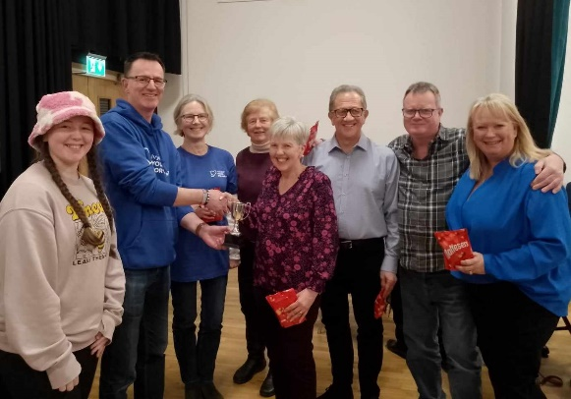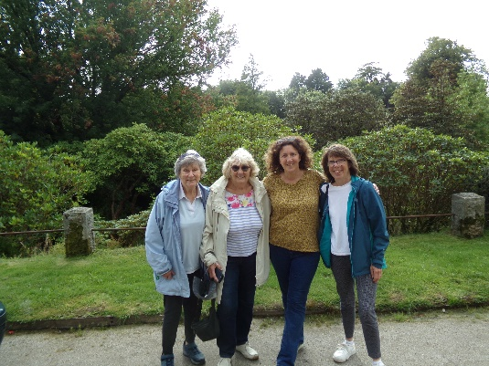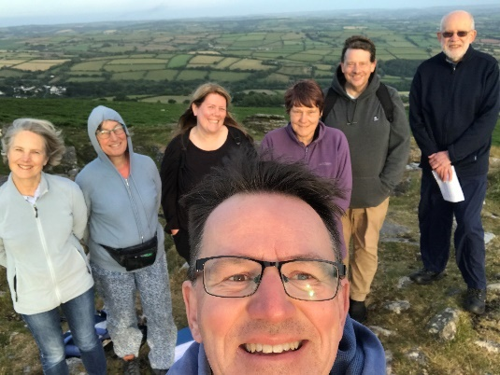

The winning quiz team, the Shine team at the Volunteer event, and the Beacon prayer walk

Conclusion

Once again, God’s faithfulness and love rescued this small charity from danger when it looked like the work was about to stop. I’m grateful to God for providing the energy, people and financial resources to help us continue at a time when many young people in our area were at their greatest need. We can now look ahead to a more positive future as we continue the work.

Ivybridge Youth for Christ
Statement of Financial Activities (Including Income and Expenditure Account)
For the Year Ended 31 August 2024

Unrestricted Restricted Year Ended Year Ended
31 Aug 24 31 Aug 23

£ £ £ £
Income and endowments from:
Donations and Legacies 53,317 2,067 55,384 48,689
Charitable Activities 2,476 - 2,476 - Investments 540 - 540 173
______ _____ ______ ______
Total Income 56,333 2,067 58,400 48,862

Expenditure On
Charitable activities 51,340 549 51,889 56,864
______ _____ _______ ______
Total Expenditure 51,340 549 51,889 56,864

______ ______ _______ ______
Net Income/ (expenditure) 4,993 1,518 6,511 (8,002)

Transfer between funds (5,956) 5,956 - -
______ _____ _____ _____
Net movement in funds (963) 7,474 6,511 (8,002)

Reconcilation of funds:
Total funds brought forward 10,630 20,758 31,388 39,390
______ _______ ________ ______
Total funds carried forward 9,667 28,232 37,899 31,338
===== ====== ====== ======

The statement of financial activities includes all gains and losses recognized in the year.

All income and expenditure derive from continuing activities.
IVYBRIDGE YOUTH FOR CHRIST
BALANCE SHEET
AS AT 31 AUGUST 2024

2024 2023
£ £ £ £

Fixed Assets
Motor Vehicles 1,582 2,373

Current Assets
Debtors 915 806
Cash at bank and in hand 35,605 28,467 ______ ______
36,520 29,273

Creditors: Amounts falling (203) (258)
Due within one year _____ _____

Net current assets 36,317 29,015
Total assets less current liabilities 37,899 31,388 _____ _____
Net assets 37,899 31,388 ===== =====
Income Funds
Unrestricted funds 9,667 10,630
Restricted funds 28,232 20,758
_____ ____
Total funds 37,899 31,388
===== ====

Accounts Approved by the Board of Trustees on 16 April 2025.
Serving Trustees – Sep 2023 – Aug 2024

Madeline Allen became a trustee on 26 April 2023. She took over the role of Chair of Trustees on 11 July 2023. Madeline worships at Ivybridge Methodist Church. She serves a Street Pastor in Plymouth and has been a swimming instructor for many years. Madeline stepped down as a trustee at the AGM on 11 May 2024.

Dave Beard became a trustee on 4 October 2022. Dave worships at Rediscover Exeter. He grew up in South Africa and was involved with Youth for Christ events in his youth. Dave is a Product Manager with HSP Group. Dave served as Treasurer until he stepped down as a trustee at the AGM on 11 May 2024.

Mike Cade became a trustee in January 2022. Mike is serving as the Safeguarding Officer for Ivybridge Youth for Christ as well as taking over as Chair from Madeline. Mike worships at Bittaford Methodist Church, is a local preacher and has previously served as a Street Pastor. He has recently retired from his position as Head of RE at Eggbuckland Community College.

Myers Cooper became a trustee at the AGM in March 2019. He has worked in electrical engineering, software development and mission and church administration and is currently a company director. He has served in Christian youth work and church leadership and is now the executive director of Cambodian Communities out of Crisis. Myers was serving as Secretary until he stepped down as a trustee at the AGM on 11 May 2024.

Kate Duckering joined the trustees in November 2012 and held the post of Chair until July 2023. She is retired from her role in the human resources team at Torbay Hospital. Kate worships at Ivybridge Methodist Church. Kate stepped down as a trustee at the AGM on 11 May 2024.

Rachel Harris joined the trustees in May 2024 at the AGM. She is Head of Centre at Brocks Farm part of Breakthrough Transformation Trust and worships at Rediscover Church Exeter. Rachel was appointed Secretary at the meeting of 28 May 2024.

Gareth Higgs (Rev. Dr.) joined the trustees at the AGM in May 2024. This summer he has moved on from his position as Superintendent Minister at Plymouth Methodist Central Hall to commence work as a Lecturer in Applied Theology at Moorlands Bible College. Gareth is currently serving as Treasurer.

Paul Hinckley (Revd.) joined the trustees at the AGM in May 2024. He is currently the vicar of Ivybridge, Cornwood, Harford and Sparkwell.

Andy Hutchinson (Dr.) became a trustee on 28 January 2022. Andy has a background in church leadership and English teaching and currently works for Compassion UK. Andy stepped down as a Trustee on 11 September 2023.

Council of Reference

Ian and Ruth Hammond (Lt) were the leaders of the Salvation Army in Ivybridge and have now moved to Whitleigh in Plymouth.

Marian Langsford (Dr) is a retired GP who worked in Ivybridge for over 20 years. Marian co-leads the Emotional Logic charity with her husband Trevor and worships at St. John’s Church, Ivybridge.

Jonny Libby works for Plymouth Methodist Central Hall and has a lot of experience working with youth and young adults. He is passionate about his faith, family, food and football.

Jeff Stephenson (Dr) was Medical Director at St Luke's Hospice Plymouth, where he worked as a doctor for over 15 years.

Lois Stephenson (Dr) Lois is a primary school teacher and has had a long interest in children and young people’s work. Lois and Jeff worship at St Matthias Church, Plymouth.

Charity Number: 1118117
Charity Address: Ivybridge Youth For Christ
16 Tom Maddock Gardens, Ivybridge, PL21 0WE

